The first thing we are going to do is setup logging for logon events. The first thing that needs to be done to do this is to open the Microsoft management console which can be done by searching for mmc in the search bar.

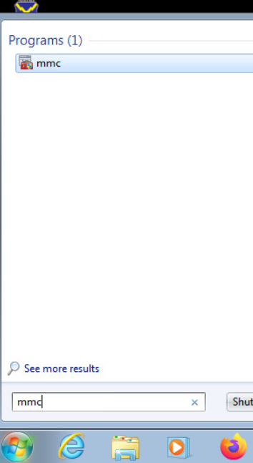

Next, we need to add a snap in within the console we just opened, this can be done by clicking on file then add/remove snap in.

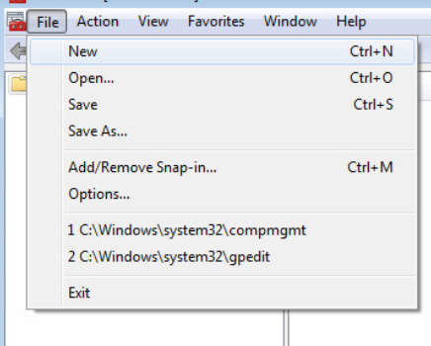

We are going to add the group policy object snap in so highlight it by clicking on it in the list on the left then click the add button then finally the ok button. 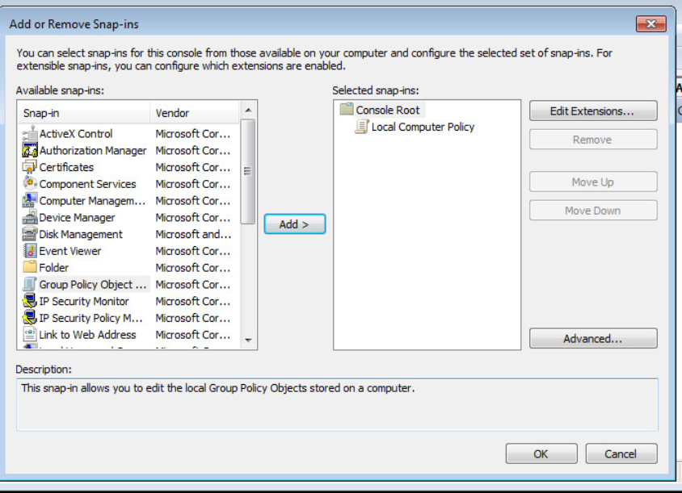

Then browse to Computer Configuration\Windows Settings\Security Settings\Local Policies\Audit Policy on the left. Next scroll down on the right side until you see the audit logon events item.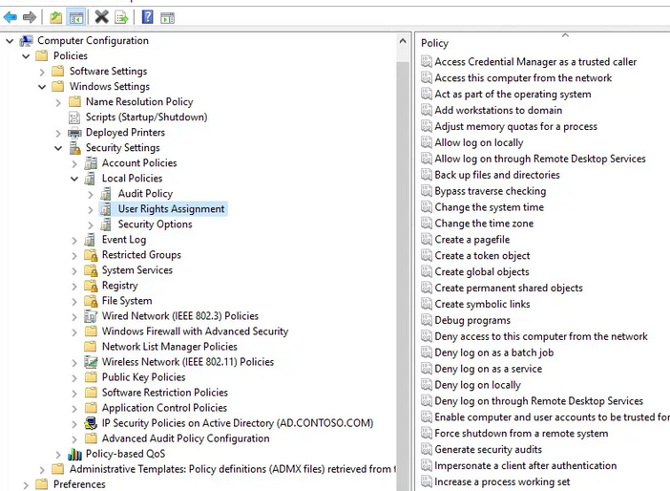

Then double click on the property to change and set it to audit successes and failures and click ok.

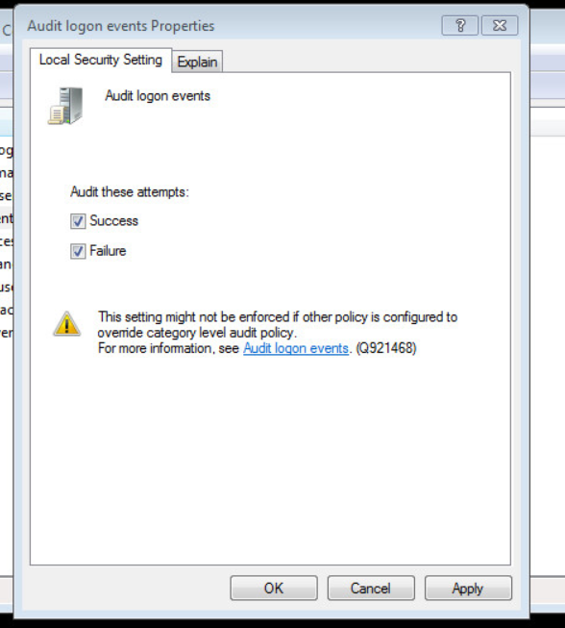

The next item to fix is to limit who can use blank passwords. Using the mmc console that is open browse to the security options instead of audit policy and find the policy limit local account use of blank password to console only and enable it.

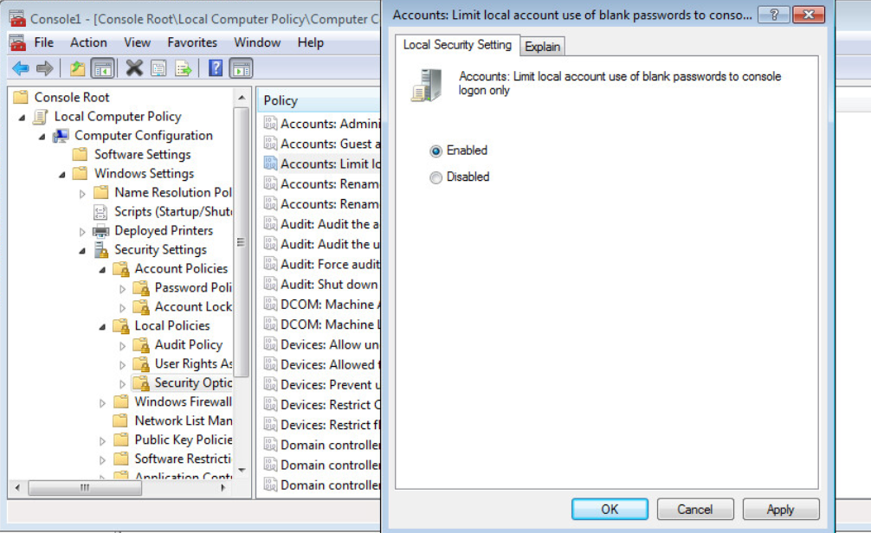

Now we are going to secure the windows logon screen by not showing the last name username used. Under the security options scroll down and find the do not display last username and enable it.

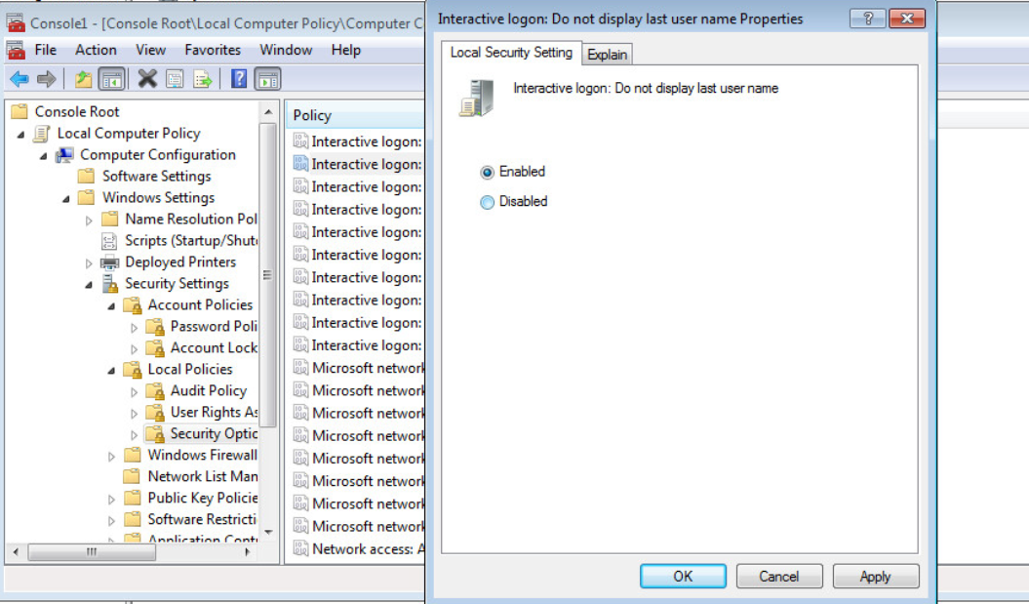

Then next security setting to configure is the do not require ctrl alt del property. In the same mmc console scroll down until you see it and set it to disabled.

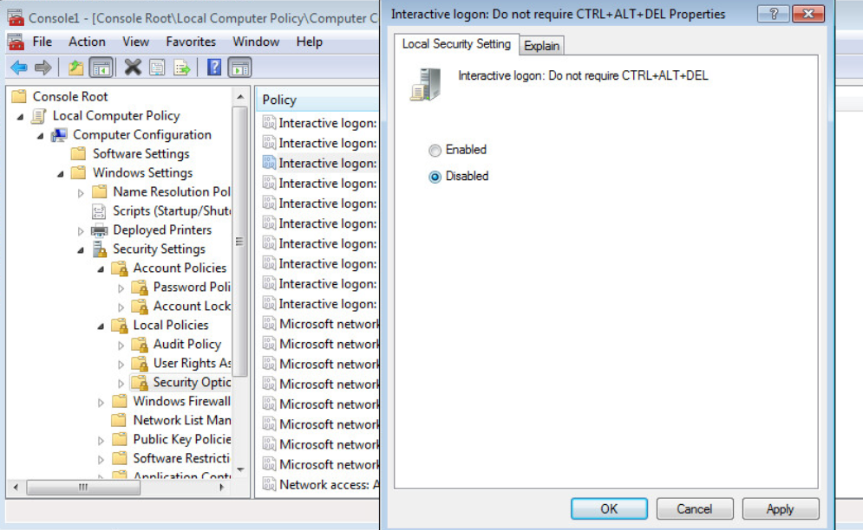

Finally scroll down until you see the prompt user to change password before expiration and set it to 10.

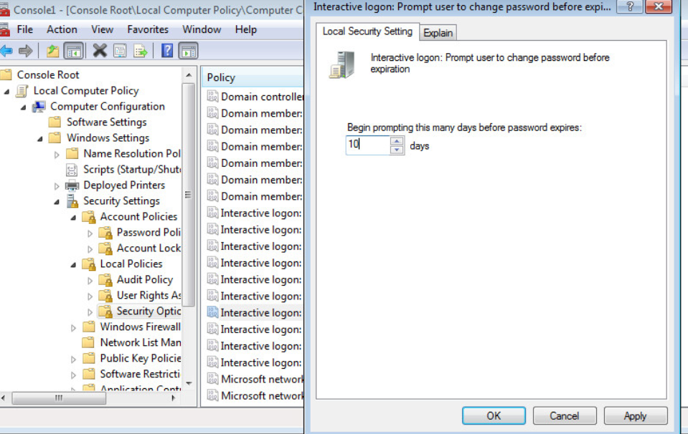

Now we are going to manage who can login over the network, this is done by going to the user rights assignments and finding the deny access to this computer from the network and open that policy. Then click the add user or group.

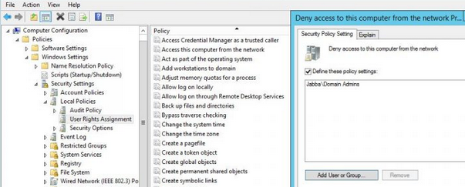

Then type the name of the users we want to deny access to in this case we only want to add Guest then hit ok.

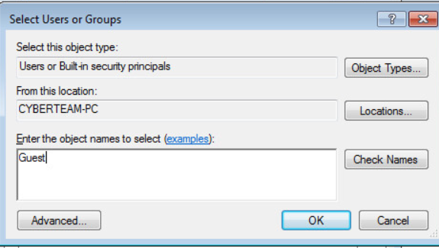

Then the policy should look something like this, and you can click ok one more time.

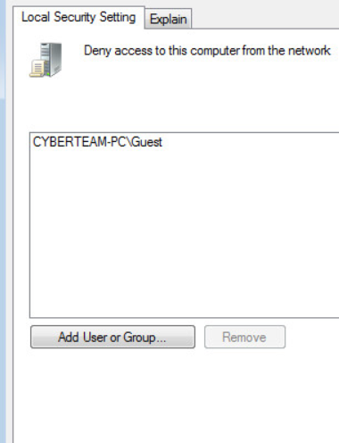

Next, we are going to secure the password polices first browse to Computer Configuration\Windows Settings\Security Settings\Account Policies\ Password Policy. Then we are going to set policy password must meet complexity requirements to true.

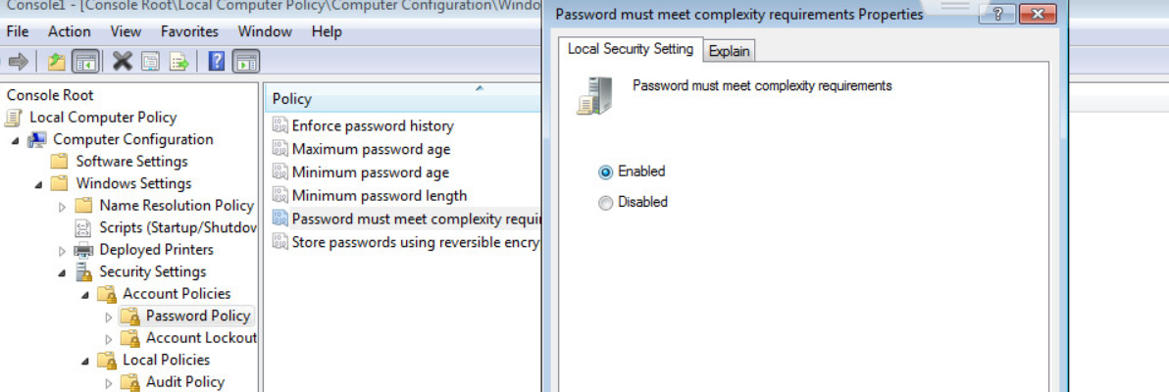

Now we need to set the maximum password age to 90.

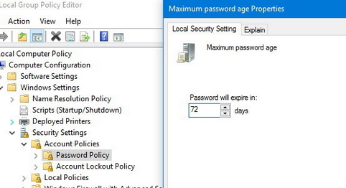

Now we are going to move to account management, first open the windows menu and then right click on computer and select manage.

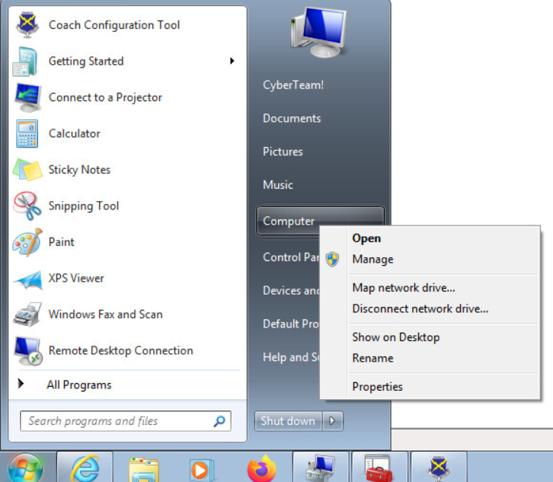

Then browse to Computer Configuration\System Tools\Local Users and Groups\Users

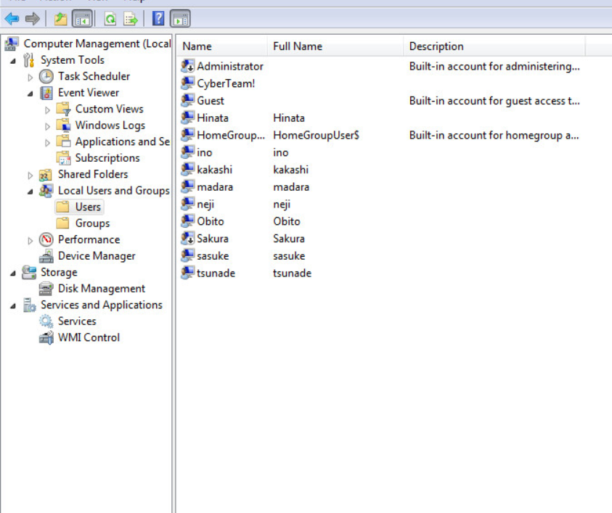

Fisrst we are going to take a look at the settings for the user account Hinata by double clicking on it. Then we scan see she never has to change her password uncheck that box and click ok.

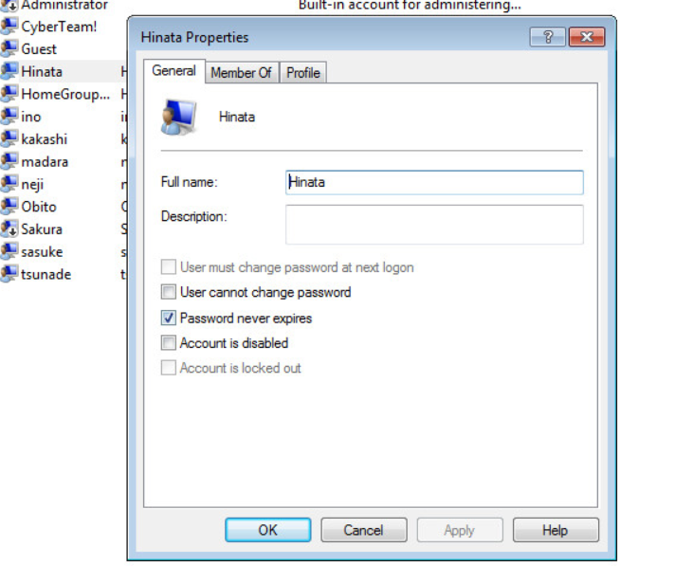

Now we are going to reset the password for the Hinata account by right clicking on it and clicking set password.

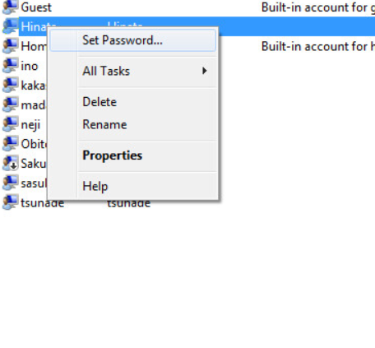

Then you will see this conformation window and you will want to click procced.

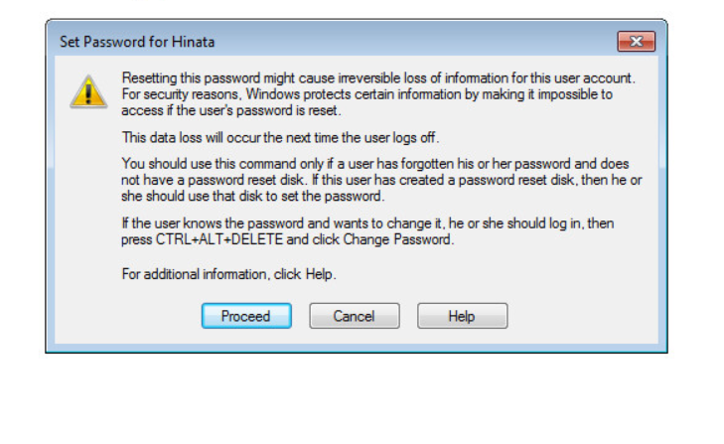

Enter a new password and confirm it then click okay. For some reason when scoring password resets the program responsible for scoring will occasionally stop thinking that the password has not been changed so if you lose points you can just reset the password again.

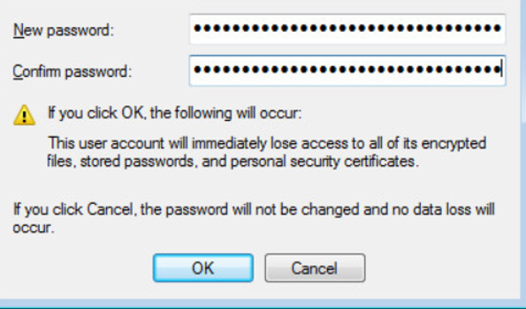

Now we are going to look at the account Sakura and we can see that it is disabled looking at the readme this is a valid account so we will want to uncheck that box and click ok to enable it.

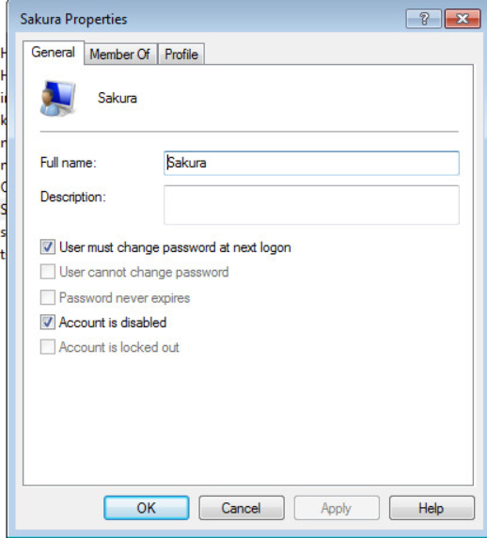

Now we are going to move on to managing groups so we will move over to the Groups screen. There is an extra group Team 7 that does not need to be there so that can be deleted. This can be done by right clicking on it and selecting delete.

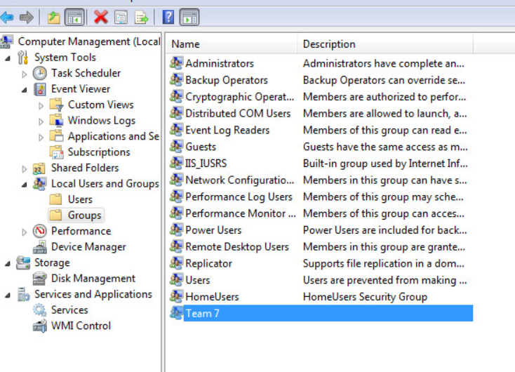

Next we need to enable the firewall this can be done by searching firewall and opening the windows firewall.

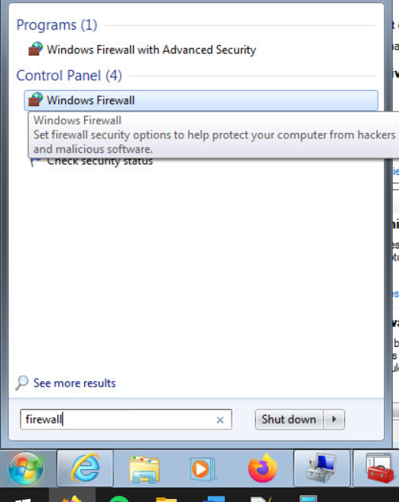

You should then see a screen like this, and you can just click the use recommended settings button

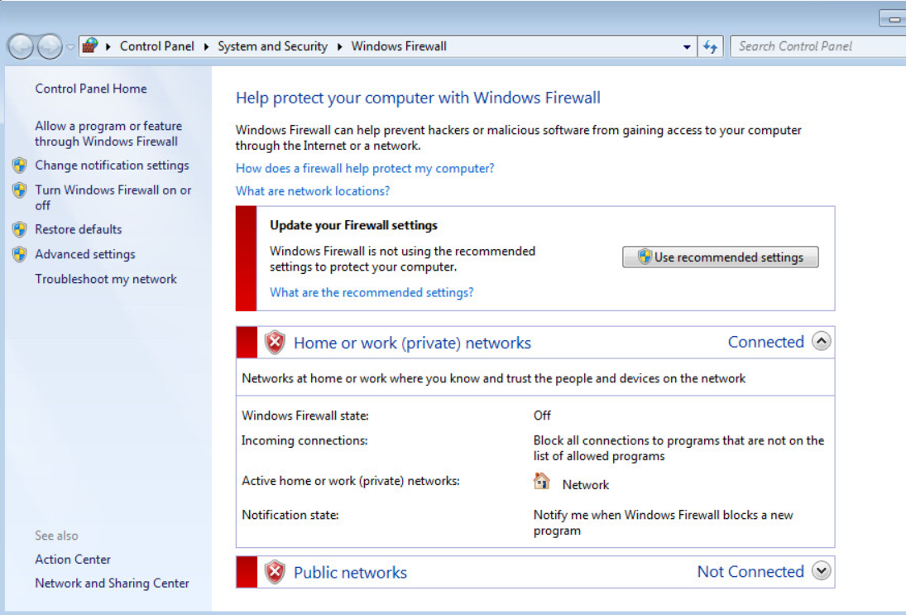

Now we want to enable automatic updates by searching for updates and opening the windows update.

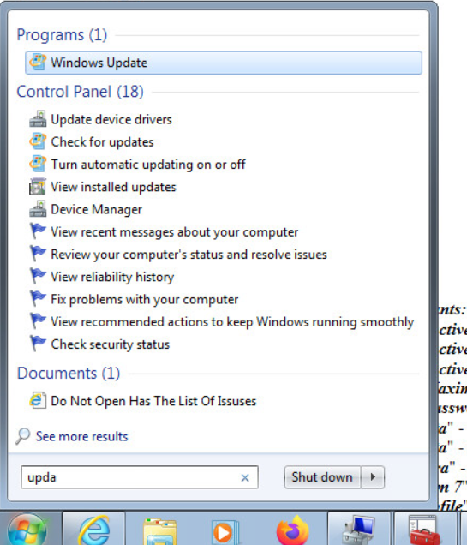

You can then click turn on automatic updates.

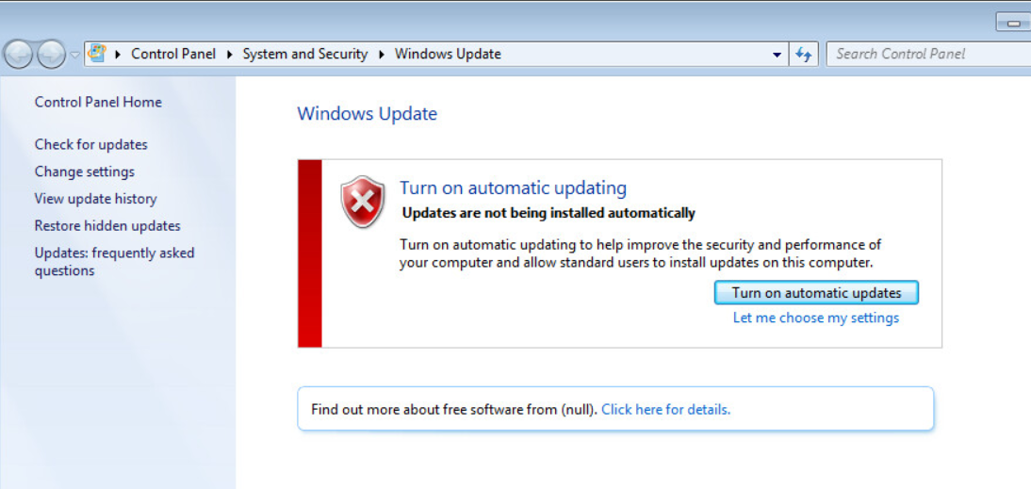

Using the window, we just opened for the updates on the top bar you can click on control panel to get to this screen. Then we want to check the installed programs by clicking uninstall a program.

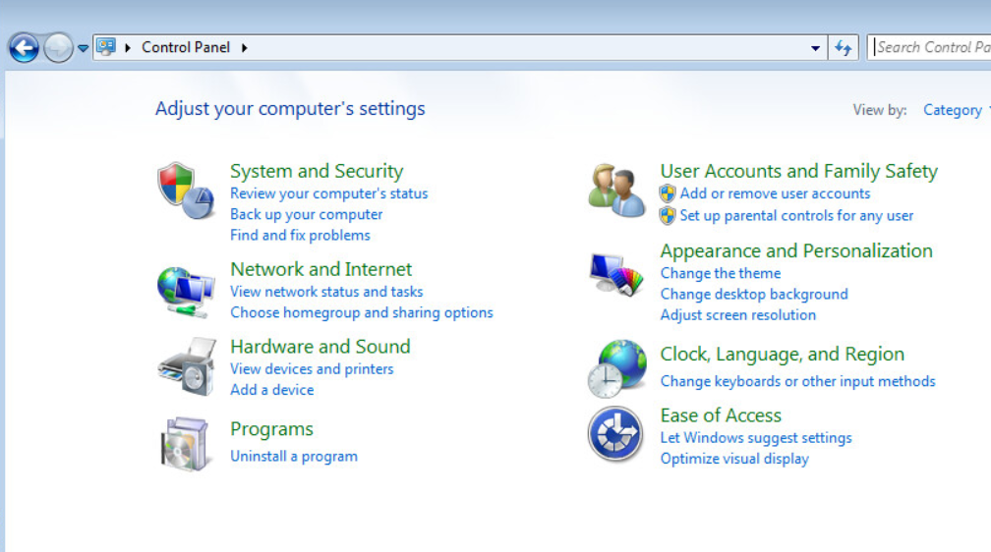

The last thing to change is to uninstall the G hub program by logitech this can be done by selecting it and clicking the delete button that appears.

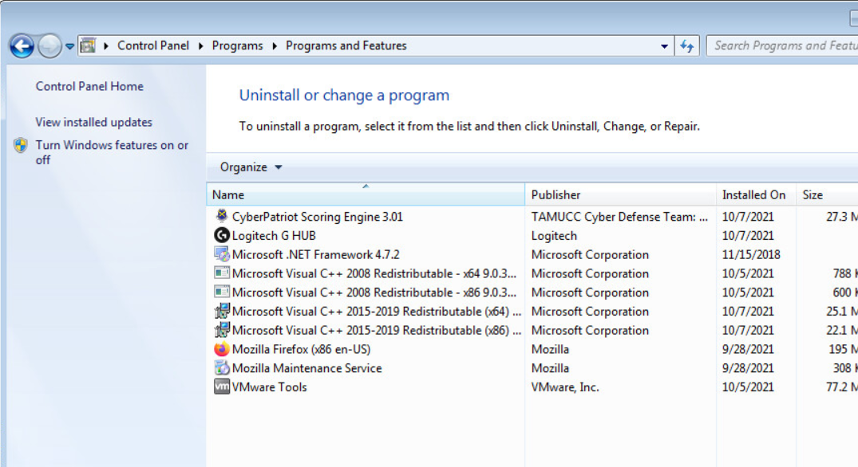

This is what the score report should look like after all scored vulnerabilities have been properly addressed

